**LAB 3 REPORT**

Name: Jiasen Zhou

Student No: 491302

Lab Screenshots/images ：

* 1. 图形用户界面, 应用程序

     描述已自动生成Telegram testing: show that the bot is properly echoing sent text messages
  2. Capacitor testing: show the serial monitor as it updates to your touch (under tools tab)

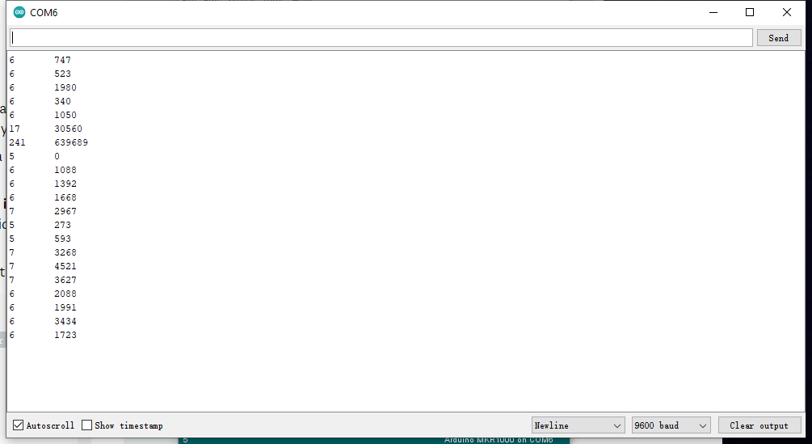

* 1. Final circuit image

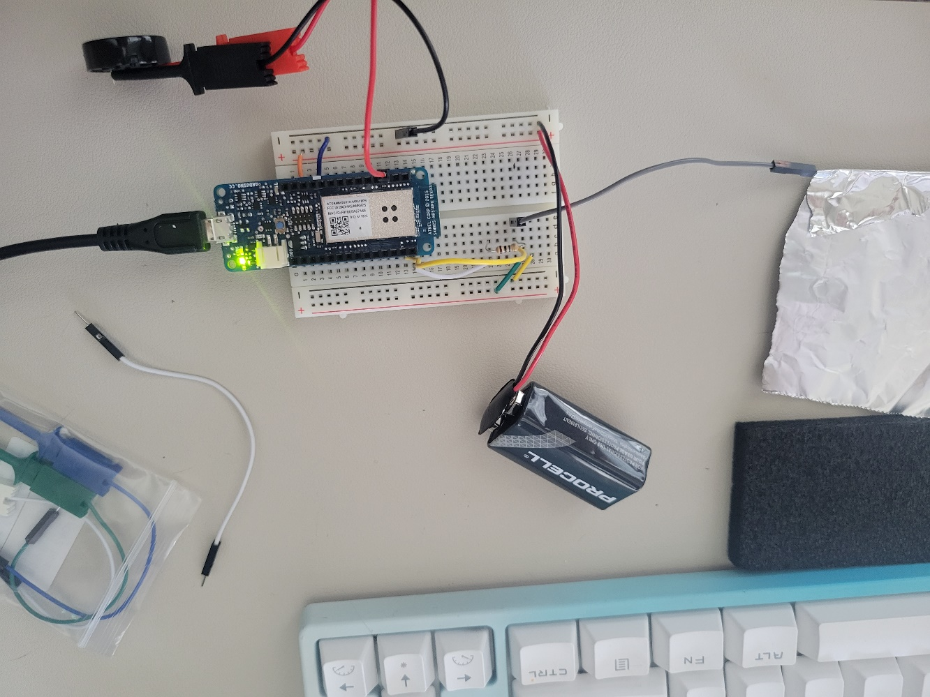

* 1. A short video of your circuit beating when you touch the sensor, and stopping when you remove touch

[Video is uploaded on canvas with this report.](video.mp4)

1. Explain how the capacitive sensor creates change in the signal when someone gets close to the surface. Hint: The aluminum foil acts as only one side a parallel plate capacitor.

The aluminum foil and my hands act like two sides of a capacitor. Based on the capacitor equation C = εA/d, as my hands close to the foil, the d is decreasing, and C is increasing. Thus the board can detect change in the signal

1. When building your circuit, assume you only had a small piece of aluminum foil to use for your sensor. Explain how the threshold level will need to be adjusted in comparison to a student with a large sheet.

Based on the capacitor equation C = εA/d, with the same delta d, the bigger area of foil will have bigger change in capacity. Thus the threshold level need to be smaller than the student with larger sheet. For example, if the sheet B is 2 times larger compare to the smaller sheet A, then A’s threshold should be 2 times smaller than B’s threshold.

Reference:

Picture of telegrambot is from Muyuan Li, one of my team members.